# Overview

## Java Origins and Ecosystem

Java Card

ME

SE：主要，核心API

MP：服务器

EE：企业服务

跨平台：在Mac上编译的Java代码能够运行在windows上

## Java Language

Class：类

Package：一些外部包

Module

创建类

错误处理

## Java Design

Class

Object

Inheritance

UML:

如何分析和架构应用

## Java APIs

### Collection APIs

List

Sets等等

### Stream APIs

使用lambda表达式，操纵大型数据

### IO APIs

### Concurrency API

多线程

### Persistence API

数据库

### Java in the Enterprise

必须在容器中才能进行部署

# Object-Oriented Concepts

汇编器 assembler

Alan Kay

抽象

对象的基本形式

>> 分析工作，分析必要的属性和方法

封装

将复杂内容进行封装而不用关注内部的实现，确保对象和主程序不会相互影响

>> 仅通过发送消息来实现内部状态的修改

继承

>> 子类重用父类代码的能力

多态

>> 将IF ELSE语句迁移到运行时的虚拟机内

>> 延迟绑定/动态绑定

# What is Java Program

特性：

1. JVM
2. OO Language  
   好处：模块化、实现信息隐藏、代码复用、维护性提高  
     
     
   组成：
3. Java Class：基本的组成部分
4. Java Packages：用于将Class组合起来的东西

IDE：

NetBeans

Read-Evaluate-Print Loop(REPL):

JShell

# Java Text and Numbers

variables

1. initialized with a value
2. change
3. specific type of data

use of variables

1. holding data
2. assigning the value of one variable to another
3. mathematical
4. print

Basic Value type:

int

double

Constants：

**final**

Operators：

1. 括号
2. ++ and --
3. * and /
4. + and -

Boolean Expressions

Primitives can be compared with relational operators, e.g. >.

Objects can be compared with operations, e.g. equals.

Java Documentation provides the reference for the classes and their operations, e.g. String.

# Java Arrays, conditions and Loop

conditions:

if else

switch

arrays:

initialize

set value

use the args in the main method

loops:

1. while loop
2. do while loop
3. for loop and **enhanced for loop**
4. for each loop

break, continue

# Java Class and Objects

Using UML diagrams：

class name

fields: data types

methods: method parameters

methods:

<access modifier> <return type> <method name> (<parameter list>) {

// body

// return statement

}

Using Method Overloading:

have the same name

have the different parameter list

## Scope and Access

Variable:

1. instance variables
2. local variables
3. “block” variables

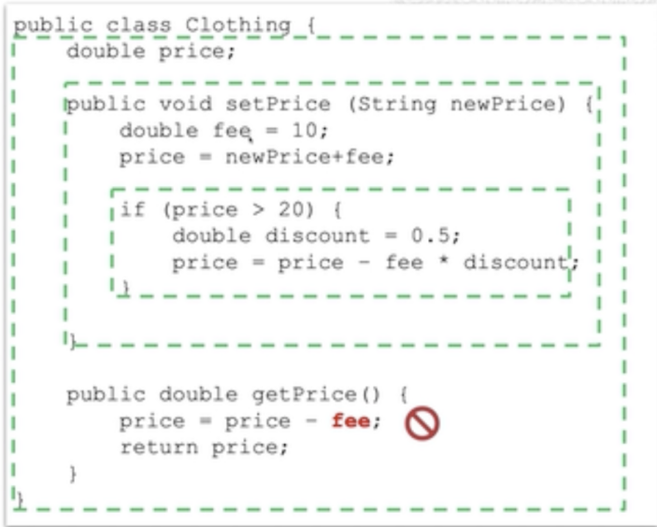

variable shadowing:

this: disambiguate from other parameters

access modifiers:

public

private

Exercise 5-1 Apply Encapsulation

Exercise 5-2 Overload a Method

Exercise 5-3 Associate "Customer" with "Clothing"

## Objects Reference and Memory Allocation

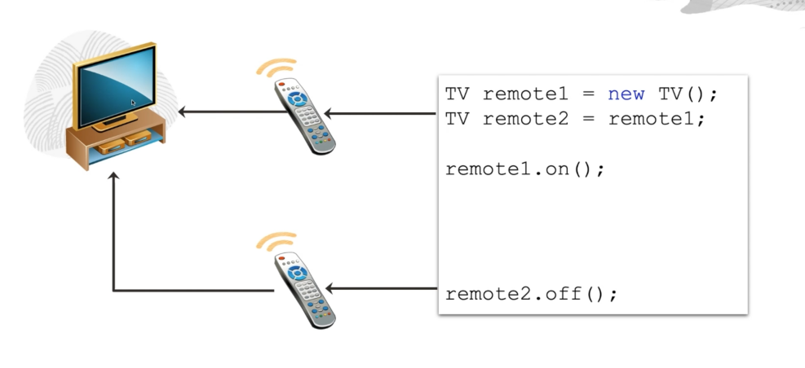

variable in memory: Stack

objects in memory: Heap

object:

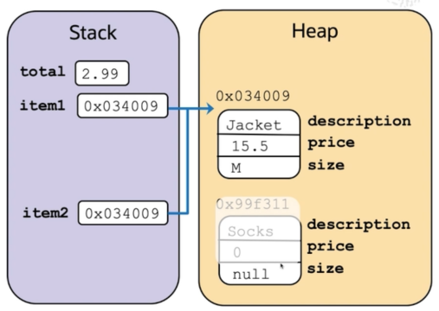

array:

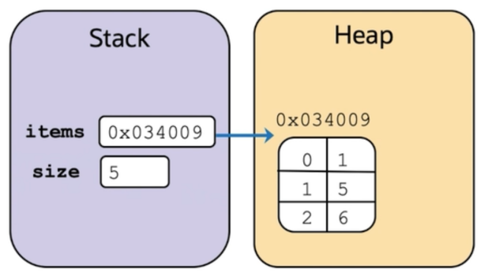

array of object reference:

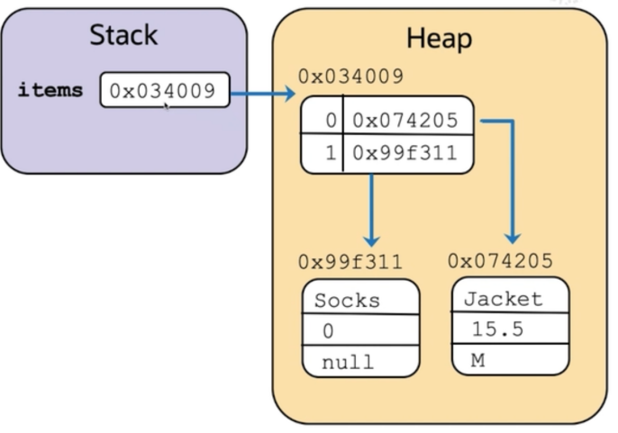

## Constructor

initialization object

6-1

6-2

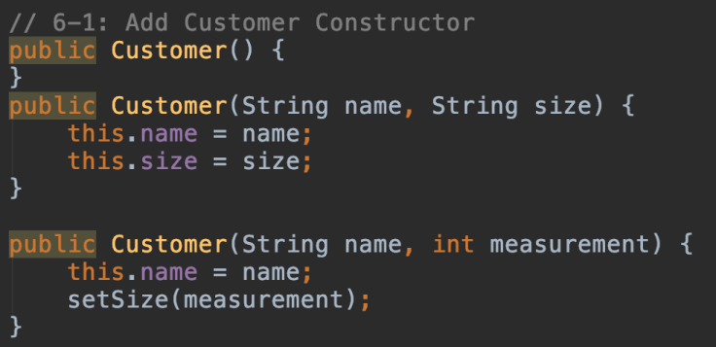

## Static

1. belong to the class and is shared by all objects
2. is not specific to any object instance
3. **not** need to initialize objects when use it
4. static method can not see instance variables
5. static method can see static variables

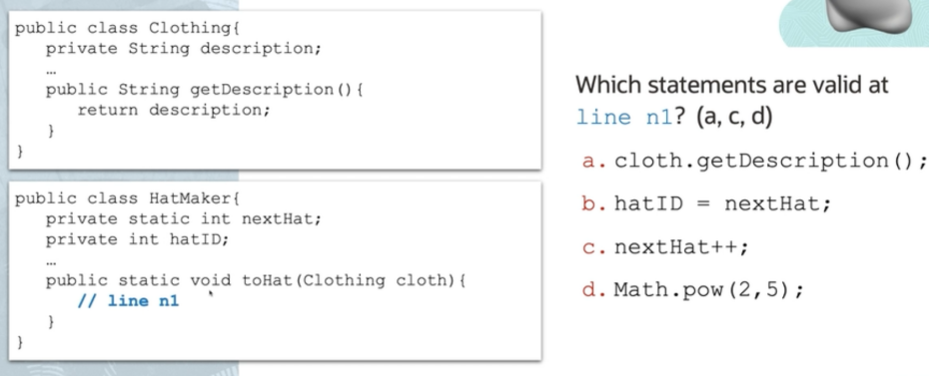

exercise 6-3

# Exceptions

exception types

exception methods

exercise7-1

# OO Approach

## Inheritance

extends class and reuse super-class logic

1. A subclass inherits the code of its parent super-class and can add its own code
2. extends of Object is implied by default
3. A java class can extend only one immediate super-class

@Override

1. define the method whose signature matches the parent class method
2. can provide an alternative algorithm for the parent class method
3. can still reuse parent method logic using super reference

Polymorphic:

Subclass method can override the super-class method.

Abstract

## Interfaces

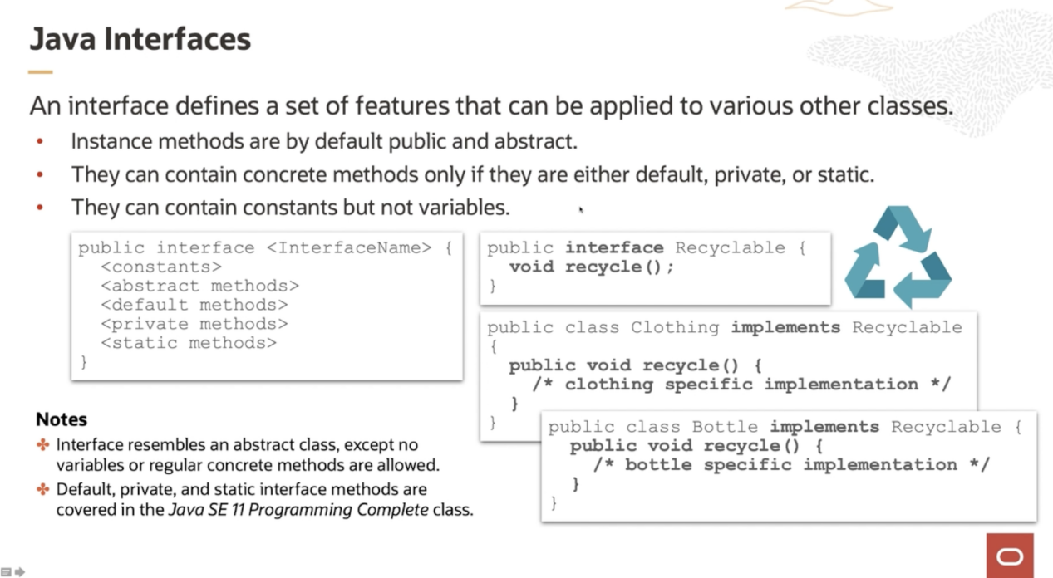

interface无法被实例化

a class can implement as many interfaces as required

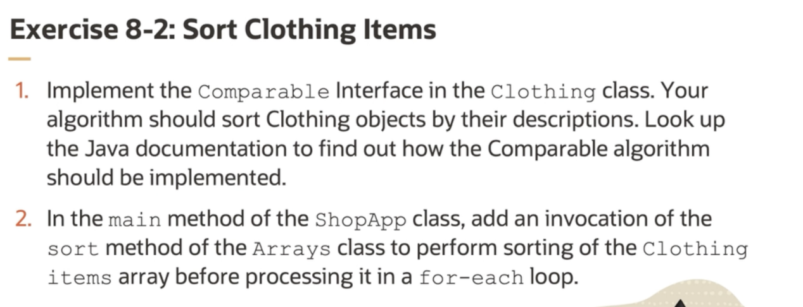

# Using Oracle cloud and Helidon

SE

->

EE

# Case Study

# Continue Learning

## 学习资源

1. java basis
2. java se11 programming complete
3. developing applications for the java EE 7 platform

相关学习资源

1. 前端
2. Java性能调优
3. OOAD with UML?

新的学习资源

1. JDK Beyond SE11
2. Exploiting Modularity?

## 认证

1. SE
2. EE

## 方法论，工具和科技

1. OO的建模系统
2. 创建高效算法和设计模式
3. 正确使用数据结构和集合
4. 联系Java面试技巧和技术

## Live Sessions

1. 和导师、产品经理、咨询师以及事件专家（SMEs）的线上直播活动
2. 在线问问题和互动的机会

内容包括：

1. 最新热点
2. 怎么去做
3. 最佳实践
4. 考试准备
5. 成功故事